**Tools / Equipment**

* Laser cutter
* 2D Design
* Sketch up
* Clock Mechanism

<http://www.ycbclocks.co.uk/>

* LED Strip
* PVA
* Acrylic
* MDF / Plywood
* Soldering iron
* USB Cable

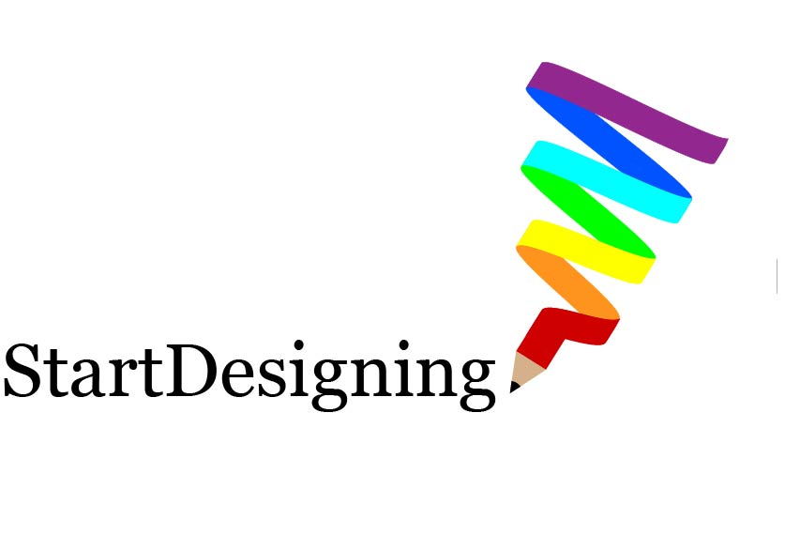

www.startdesigning.co.uk

**This is an introductory project aimed at year 7.**

**The main focus is on designing using 2D Design and CAD/CAM.**

**Visit:** [**https://en.makercase.com/**](https://en.makercase.com/) **for an easy way to make the base.**

**The base has a LED strip light in side to light up the acrylic.**

**visit:** <https://www.startdesigning.co.uk/led-strip/>

**to purchase strips and receive free example DXF file.**

**Possible Lessons:**

1 – Introduction- Research theme

2- Materials- woods/plastics- basics

3. Specification

4 – Design ideas- Paper

5- Modelling – cardboard/ paper

6. Evaluation of ideas

7– 2D Design tutorial

8 – Development of idea- 2D Design

9– Manufacture- Workshop

10– Testing and Evaluation

**Design Brief:**

Design and manufacture an LED acrylic clock inspired by a style of your choice

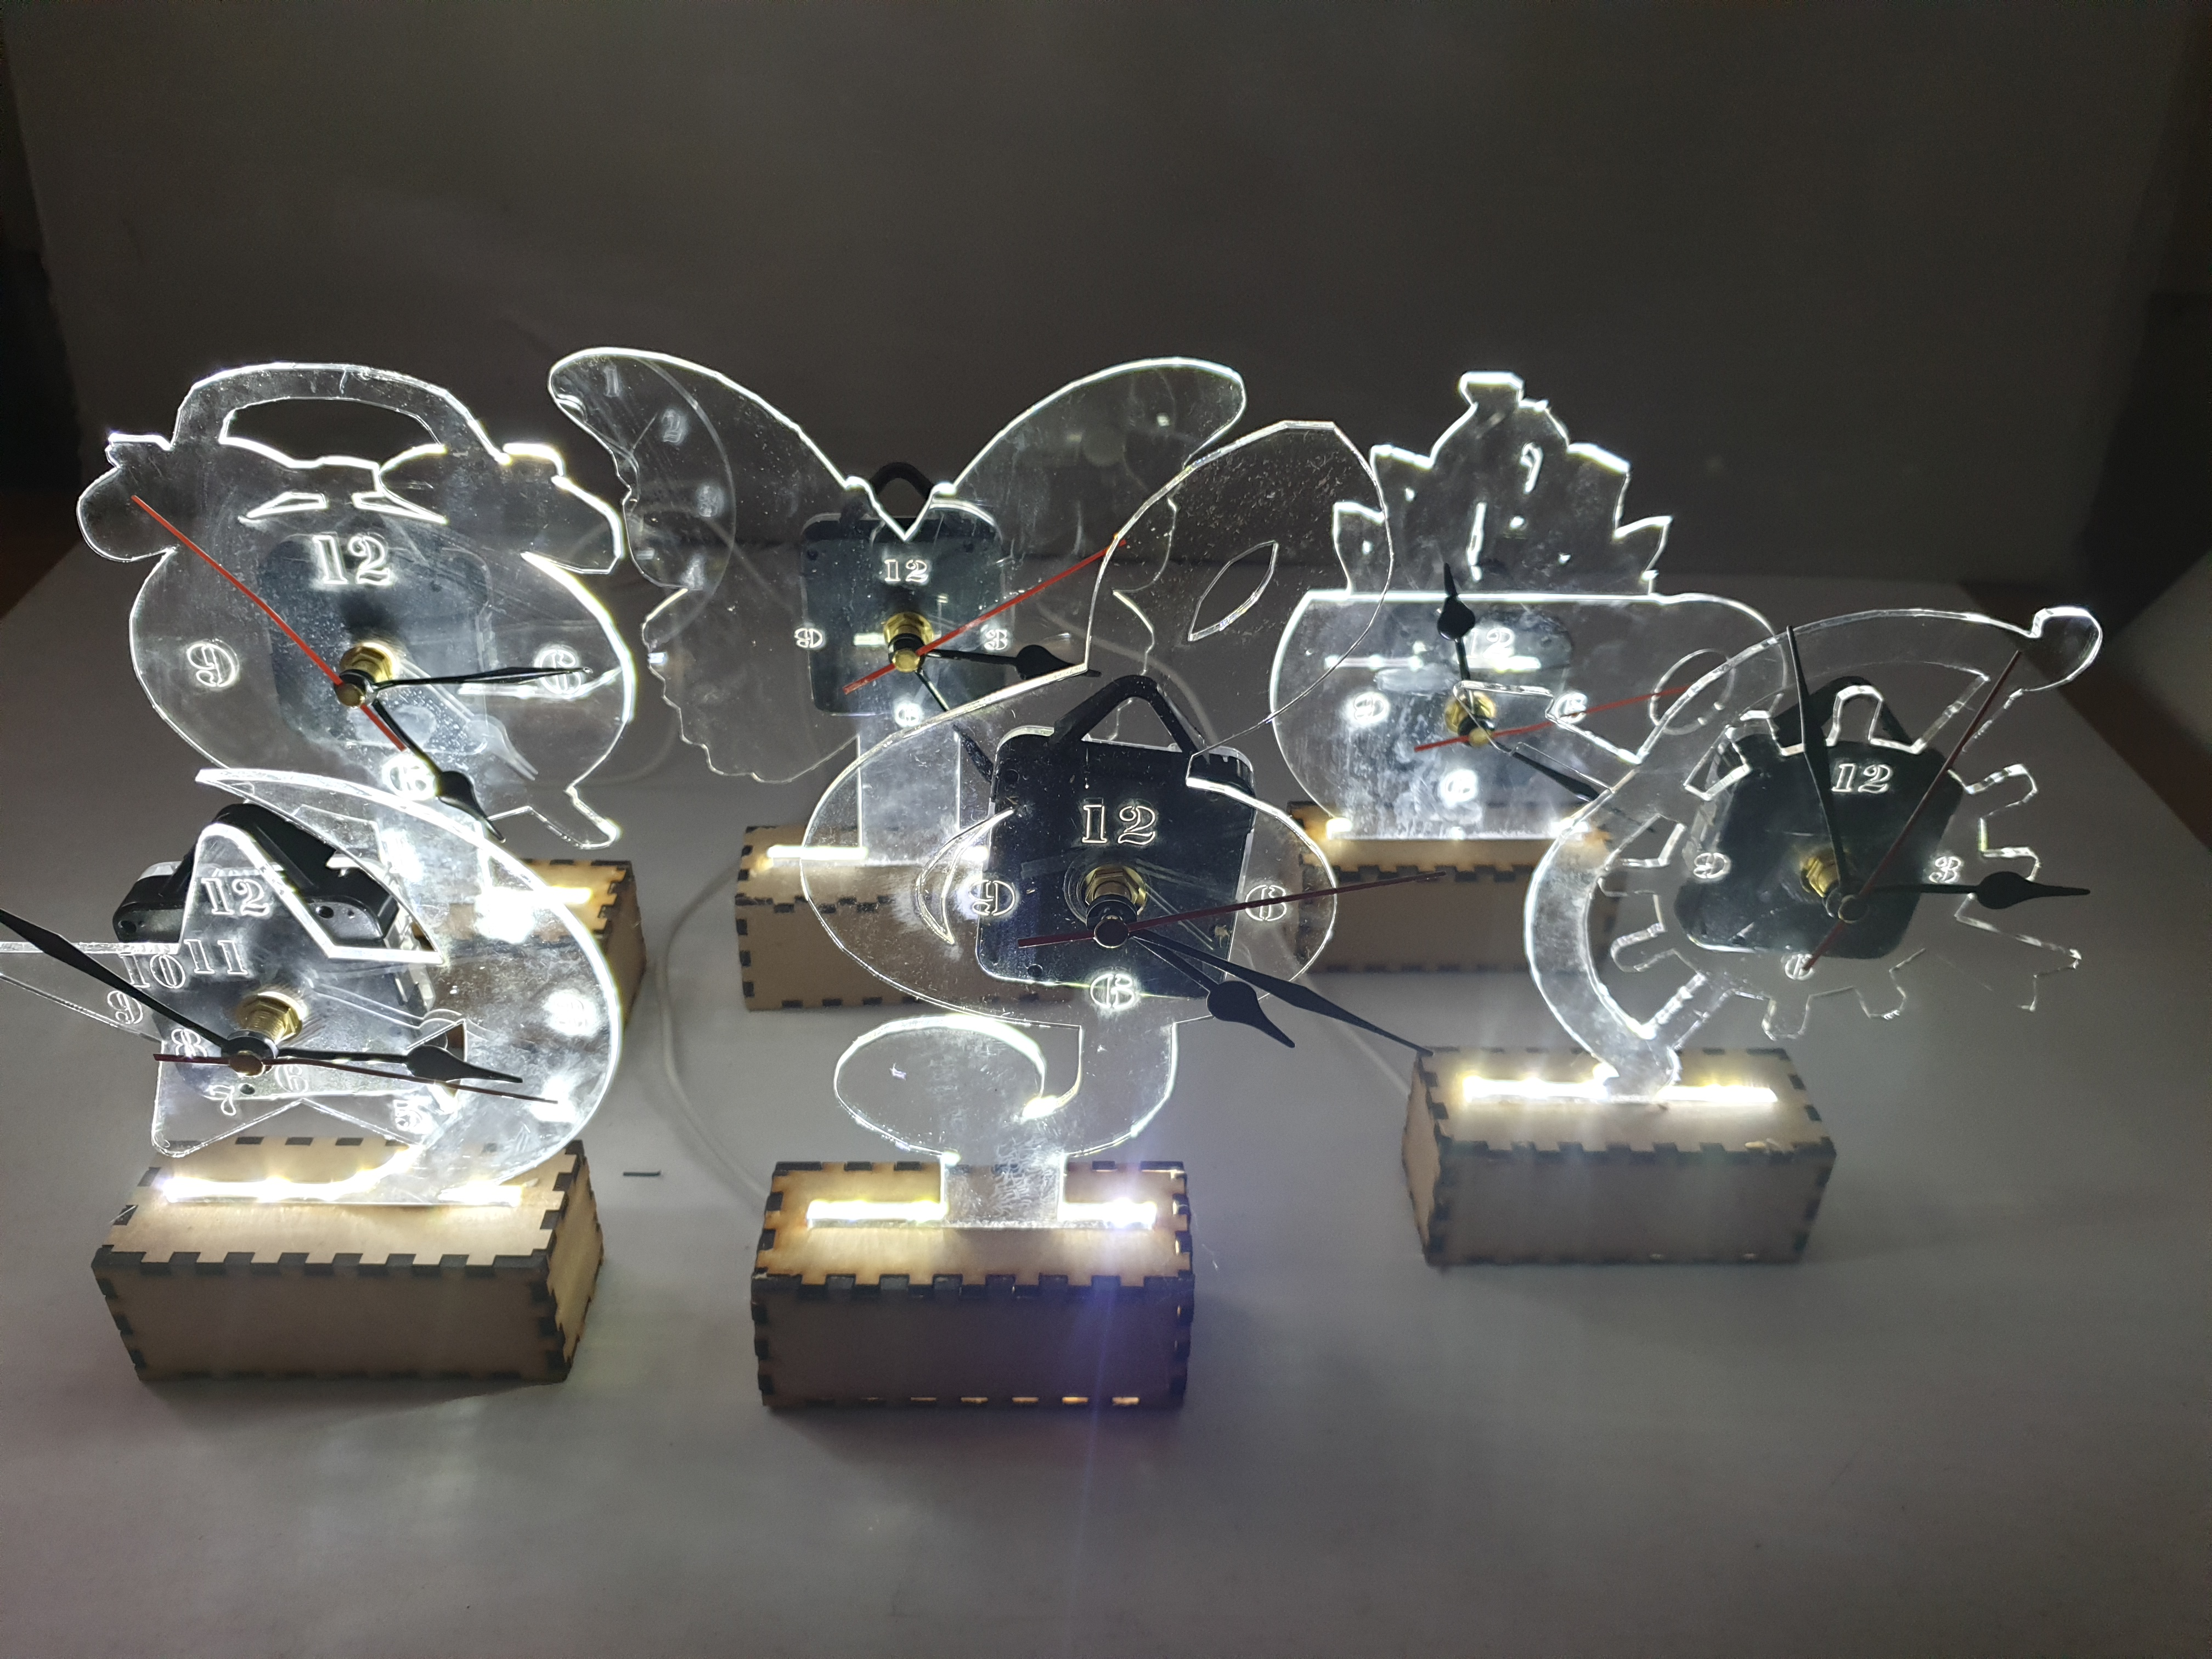

**Homework Tasks:**

1. **Research the history of clocks**
2. **What is plastic? Give examples**
3. **Research the history of light**

LED CLOCK PROJECT

**Health and Safety:**

1. Wear safety clothing appropriately
2. Ensure all hair is tied back.
3. Only use equipment you have been shown how to use.
4. Ask if you are unsure how to use a piece of equipment.
5. Ventilation for soldering.

**SMSC:**

Spiritual – Reflecting.

Moral – Expressing views

Social – Collaborative learning

Cultural – Explore cultural jewellery.

**Mathematics:**

Measurement, angles, diameter, radius, shapes, Proportion

**Literacy:**

The consistent use of specialist terminology.

Analytical and evaluation skills.

**Science:**

Plastics, sustainability

**Extension Tasks:**



1. Sketchup tutorial and design ideas
2. To produce a leaflet on your choice of design movement
3. Produce a stand using scrap wood and hand tools

**Key Words:**

Art Deco Bauhaus Memphis

Pop Art Form Function

Acrylic Plywood CAD-CAM

Materials Sketch up 2D Design